CITY OF CORDOVA
SURPLUS ITEM SALE – MARCH 2025
SURPLUS ITEM SALE LIST

Item #1 |  | 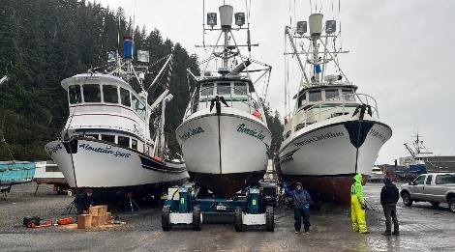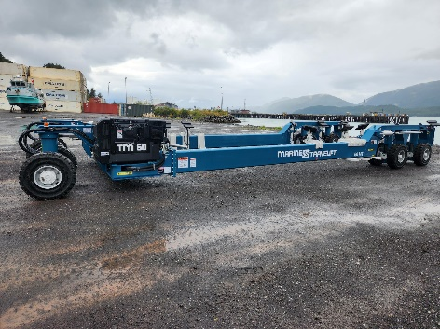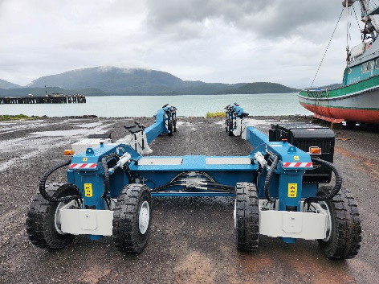
Item Name: Marine Travelift self-propelled, 60 Ton Transporter
Description: Serial. 23743
Hours: 38.9
Year: 2023
Minimum Bid: $275,000
Contact Person:  Tony Schinella  Harbormaster  (907) 424-6279 | Item Location:  Cordova Port & Harbor  123 New England Cannery Rd, Cordova, AK 99574

