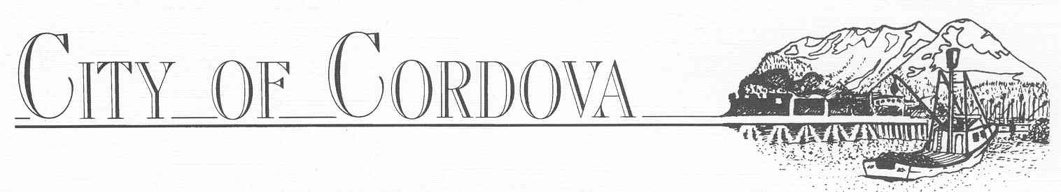
The Cordova Port & Harbor, City of Cordova offers for sale by sealed bids for the following impounded vessels

Vessel Name: Wanderer, 72-foot fiberglass Tender.
Last Owner: Brad Patterson
Address: Cordova, AK 99574.
*Vessel must be removed from city property within 90 days from date of sale

Vessel: 15-foot aluminum Skiff w/40hp Johnson outboard
Last Owner: Michael Ledford
Address: PO Box 1355 Cordova, AK 99574.
*Vessel must be removed from city property within 7 days from date of sale

Vessel Name: Dolphin Bay, 42-foot wooden pleasure craft
Last Owner: Michael Ledford
Address: PO Box 1355, Cordova, AK 99574.
*Vessel must be removed from city property within 90 days from date of sale

Vessel Name: 12-foot fiberglass Skiff
Last Owner: Unknown
Address: Unknown
*Vessel must be removed from city property within 7 days from date of sale

Vessel Name: F/V Bold Lady, 38-foot Ledford
Last Owner: Tim Miller
Address: PO Box 135, Cordova, AK 99574.
*Vessel must be removed from city property within 90 days from date of sale

These vessels will be sold “as is where is” by sealed bids to the highest bidder.
Bids accepted at the Harbor office Mon-Fri 8am to 5pm until 31 May 2022.
The vessel can be inspected by contacting the Cordova Harbormaster’s Office at
907-424-6400, Monday-Friday 8:00am-5:00pm

